
School of InfoComm Technology

Data Visualisation & Story Telling
Specialist Diploma in Data Analytics
April 2022 Semester

ASSIGNMENT 1
(Individual Assignment)

Submission Deadline:
12 June 2022 (Sunday), 12 Noon

Student Name | : | LESTER CHAN WEI JIAN
Student Number | : | S10244450
Video submission link | :

Penalty for late submission:
10% of the marks will be deducted every calendar day after the deadline.
NO submission will be accepted after 18 June 2022 (Saturday), 12:00 Noon
Table of Contents
1 PROJECT OBJECTIVES 1
1.1 Strategic Level Problem 1
1.2 What can we do better to achieve the Strategic Goal? 3
2 DATA PREPARATION 4
2.1 Multiple Counts and Repetitive Usage of Order ID 4
2.2 Repetitive Order and Shipping Dates for a Single Order 4
2.3 Differing Customer IDs for One Customer 5
2.4 Single Customer, Multiple Countries 5
3 EXPLORATORY DATA ANALYSIS AND VISUALISATION 7
3.1 Optimise/Utilise Shipping 7
3.2 Majority of Customer Base 11
3.3 Trends to Note 14
4 DASHBOARDS 17
4.1 Optimise Shipping Dashboard 17
4.2 Profit Trend Analysis Dashboard 20
4.3 Customers to Focus On Dashboard 23
5 REFERENCES 25

Figure 1-1. GPS Analogy for Questioning Data 4
Figure 1-2 - Sales vs Profit 5
Figure 2-1. Multiple and Repetitive Order ID 7
Figure 2-2. Repeated Order and Shipping Dates 7
Figure 2-3. Differing Customer IDs 8
Figure 2-4. Multiple Countries for Single Customer 8
Figure 3-1. Treemap of Countries based on Quantity Shipped 10
Figure 3-2. Country View 10
Figure 3-3. Pie Chart of % of Countries with Substantial Quantities Shipped 11
Figure 3-4. % of Categories Shipped 12
Figure 3-5. Profits of Categories Ordered by Country 12
Figure 3-6. Average Quantity per Order 13
Figure 3-7. Density Map of Customers based on Orders Made 14
Figure 3-8. Pie Chart showing Majority Customer's Most Profitable Products 15
Figure 3-9. Amalgamated Pie Chart of Majority Customer's Profitable Products 15
Figure 3-10. Majority Customer - Consumer vs Corporate 16
Figure 3-11. Sales Trend Analysis 17
Figure 3-12. Profit Trend Analysis 17
Figure 3-13. Profits of Sub-Categories 18
Figure 3-14. 2019 Q2 to Q4 vs 2020 19
Figure 4-1. Optimise Shipping Dashboard 20
Figure 4-2. Action to Display Average Quantity Ordered for a Country 21
Figure 4-3. Go to Average Quantity Sheet 21
Figure 4-4. Filter Countries 22
Figure 4-5. Profit Trend Analysis Dashboard 23
Figure 4-6. Filtering Profits when Selecting Quarter 24
Figure 4-7. Go to 2019 to 2020 Quarters Sheet Action 25
Figure 4-8. Filtering Quarters on Sheet 25
Figure 4-9. Customers to Focus on Dashboard 26
Figure 4-10. Filtering % of Profit of Sub-Categories for a Customer 27
Figure 4-11. Hover Highlight Action 27

PROJECT OBJECTIVES

Strategic Level Problem

Firstly, in order to be clear of how to ask the data the right questions, an approach was adopted from a framework introduced in the article titled “A Simple Strategy For Asking Your Data The Right Questions” (Dykes, 2020). The framework introduces a 4-step approach to asking the right questions as illustrated in the author’s depiction of using GPS guiding system as an analogy.

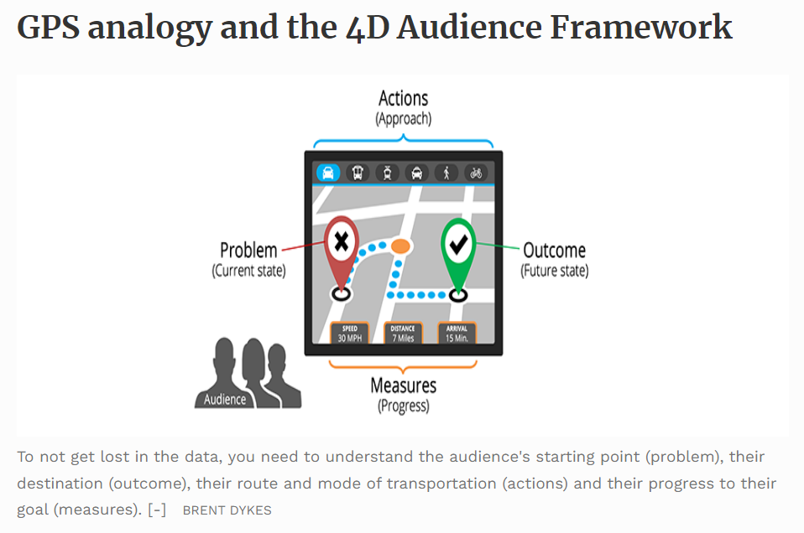
Figure 1-1. GPS Analogy for Questioning Data

A few leading problem and outcome statements were then thought of:

Problem | Outcome
What is the driving force behind setting up a business? | To make as much money as possible.
In order to make money, what does the business, specifically a retail business, need to do? | The business needs to make a profit from the sales of their products.
Now that we know how to make money, how do we make as much money as possible? | The business needs to make a healthy profit (tracked by profit margin) in the sales of their products.

This helped to establish the strategic level question – How can we improve the Profit Margin?

This helps us to think of what next will the management of a business ask: What is the state of my company’s profit margin today and should I be concerned?

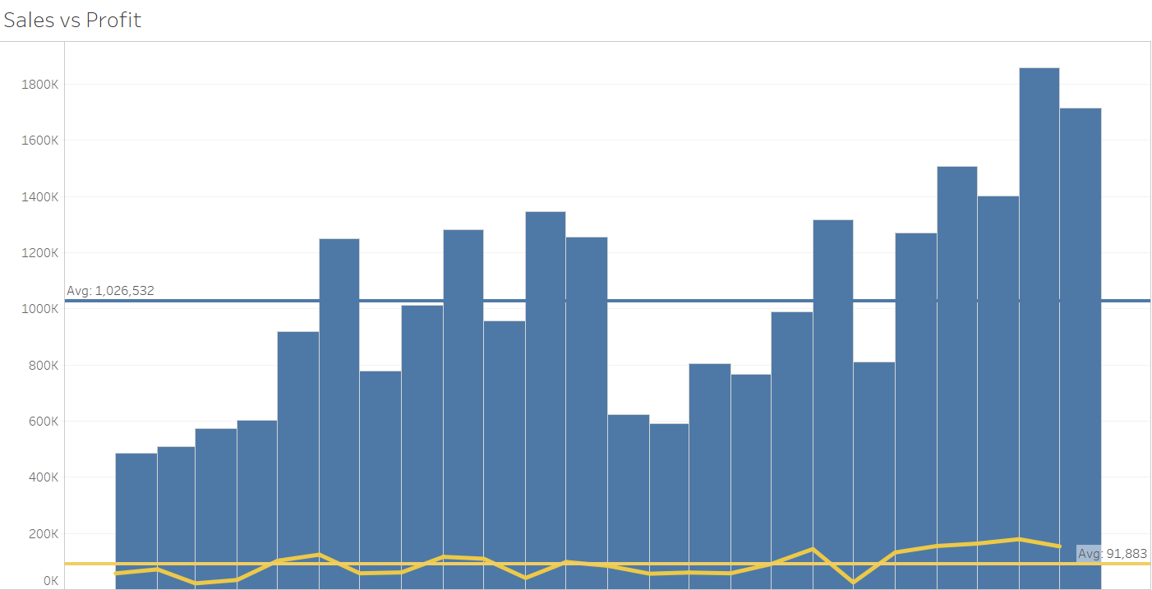
Figure 1-2 - Sales vs Profit

A quick look at the data comparing the Sales and Profit in the graph above shows that the profit margin is almost at 9%. Comparing this a data set compiled by New York University Stern School of Business (Business, 2022), which shows the average net margin for Retail (online) sits at 7.26%, the business is doing above average.

What can we do better to achieve the Strategic Goal?

There are many ways a business can look to tweak to improve profit margins. In breaking down the Strategic Goal to smaller goals, a few primary exploratory questions were thought of:

- Studies have shown that efforts expended towards existing customers is more profitable compared to finding new ones. But it would be an issue if these existing customers give us losses instead – how then can we be sure we are targeting the right bunch?
- Can a Sales Trend Analysis help to check if there are any irregularities between how much was sold vs how much the business profited?
- Does having a higher quantity sold equate to a higher profit earned? How can we check this to ensure we are directing precious time into products that will lift the profit margin of the business?
- Where does the part about countries come into play in the quantity sold and profits earned?
- Is shipping cost a factor we can investigate to help increase profit margins? If shipping fees is an expense, how can we turn this into an advantage to gain better profits out of our sales?
- Increasing the customer’s Average Order Value (AOV), that is, how many items a customer orders in a single transaction, will help to improve profit margins; how can we promote this behaviour in our customers?

From these questions, three key factors were set which would form the basis of the analysis, and recommendations to help achieve the Strategic Goal of improving the business’ profit margin:

- Optimise/Utilise Shipping. The analysis conducted on this factor aims to help the business exploit shipping.
- Trends to Note. This factor will present the business with profitable trends that they may look to jump on, affirm/deny on the profitability of certain products, and provide the business with data to highlight possible reviews in processes.
- Majority of Customer Base. Conclusions from this factor’s analysis will enable the business to be more efficient and effective in the directing of their energies.

DATA PREPARATION

The dataset initially looked clean and complete. To have an initial understanding of the data, a filter was applied to obtain an overall glance at the fields in each header e.g. to have a quick understanding of Regions vs Market. Or, what are the types of products we are dealing with.
However, upon further inspection, it seemed that there were several discrepancies which needed to be fixed. The cleaning and further research done will help to determine accuracy of the data to be analysed, and which field would be the most appropriate to use in the analyses.

Multiple Counts and Repetitive Usage of Order ID

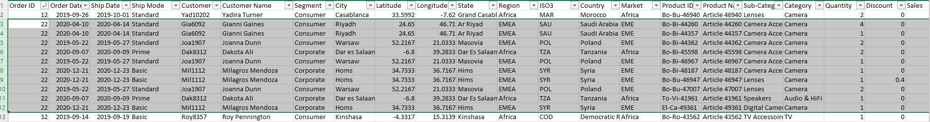
Figure 2-1. Multiple and Repetitive Order ID

The diagram above shows Order ID number 22 highlighted. As shown, the Order ID 22 is assessed to be recycled and is a reoccurring theme for most of the other Order IDs. Moreover, there does not seem to be a clear relation to how the Order ID is being created – there is no correlation to whether the ID is generated based on the Customer, the Region, the Market etc. This assessment leads us to rule out using Order ID to count the number of orders as there are multiple instances of the ID being used. Moreover, cleanup of this magnitude would be a huge effort.

Repetitive Order and Shipping Dates for a Single Order

Figure 2-2. Repeated Order and Shipping Dates

The highlighted cells in the above image shows an instance of repeated Order and Shipping Dates for a single transaction. To clean this up, we will use the Count Distinct functions as well as utilise Calculated Fields in Tableau in order to obtain the accurate values for our analysis.

Differing Customer IDs for One Customer

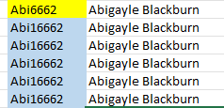
Figure 2-3. Differing Customer IDs

The image above shows an instance of this issue. Should there be a need to use this field, we will need to change one of the values to match the other one. In this example, we will assume that the value in the blue cell is the correct one, and change all the yellow cells’ values to match the blue one. This cleanup task is assessed to be of a low-moderate magnitude.

Single Customer, Multiple Countries

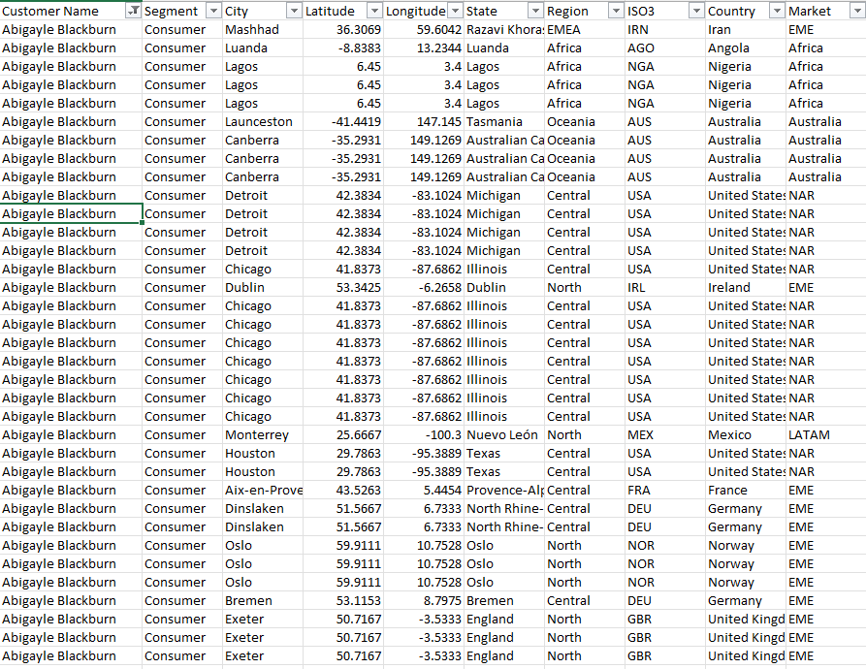
Figure 2-4. Multiple Countries for Single Customer
A key point to highlight while exploring the data was in discovering that a single customer had orders delivered to many countries which had insignificant link with each other.

Using the Customer above as an example to illustrate this point, this helps lead us to the assumption that these customers could be dropshippers who and are using this business as their suppliers and shippers to their own customers.

EXPLORATORY DATA ANALYSIS AND VISUALISATION

Optimise/Utilise Shipping

The following charts have been generated to support the analysis of this key factor. The paragraphs below the charts aim to elaborate what insights can be gleaned and how it can lead to further questions.

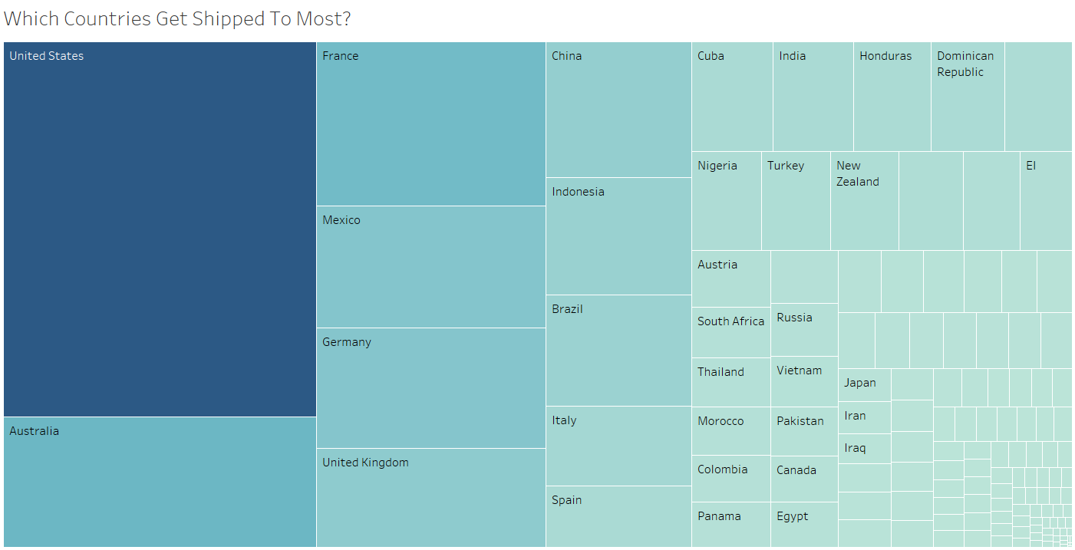
Figure 3-1. Treemap of Countries based on Quantity Shipped

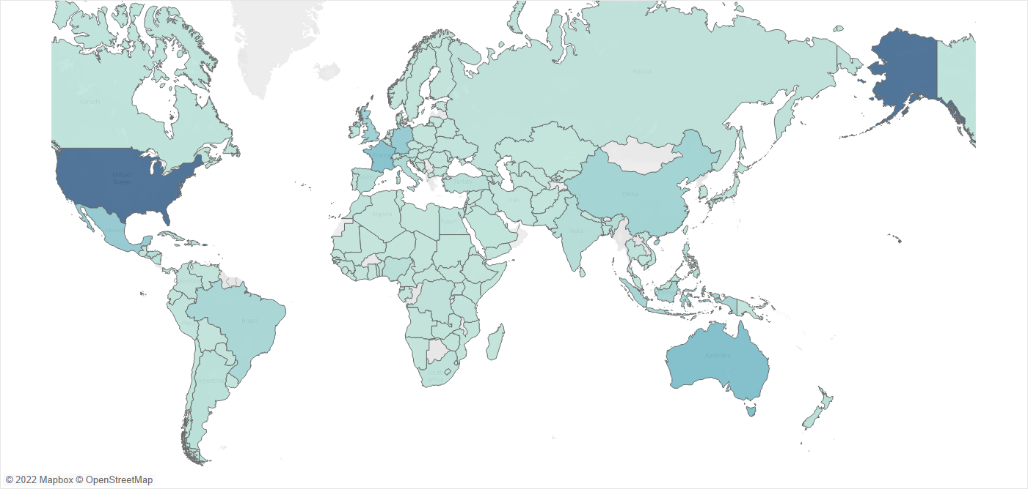
Figure 3-2. Country View
The treemap and region map above differentiates, by shades, the quantity of items shipped to various countries. Referring to the treemap, we can see that the boxes from the United States to Spain actually make up a substantial proportion of the amount of items that the business ships out, with the United States making up a significant proportion of this proportion.

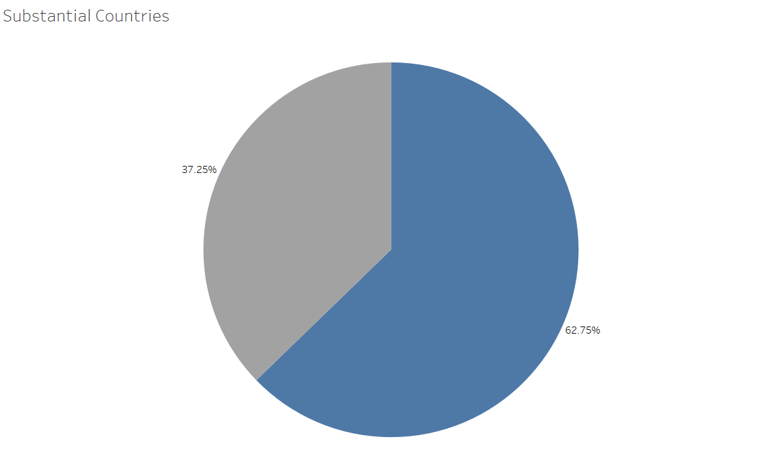
Figure 3-3. Pie Chart of % of Countries with Substantial Quantities Shipped

The substantial countries were grouped together in a set to enable a better visualisation of the percentage that their order quantities contributed to in the total. This pie chart helped to affirm the hypothesis that if the business looks to focus efforts in terms of shipping to these countries, there is potential to substantially increase the profit margin.

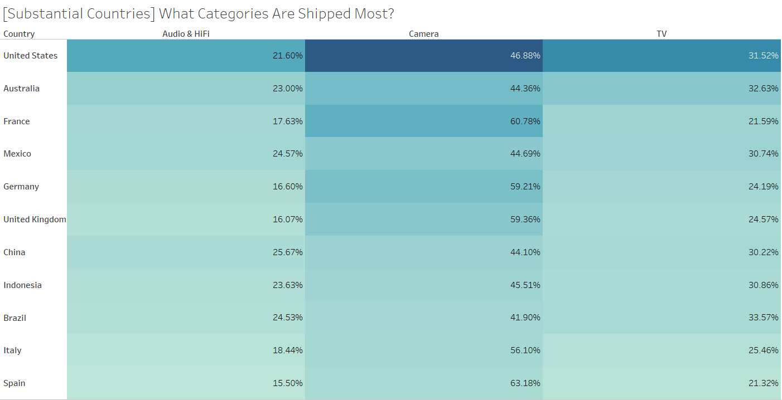
Figure 3-4. % of Categories Shipped

In the highlight table above, a further breakdown was conducted to show the ratios of Categories being shipped to the selected countries. The assessment from this shows that the Camera is the most shipped out Category in all these countries, followed by TV, and then Audio & HiFi.

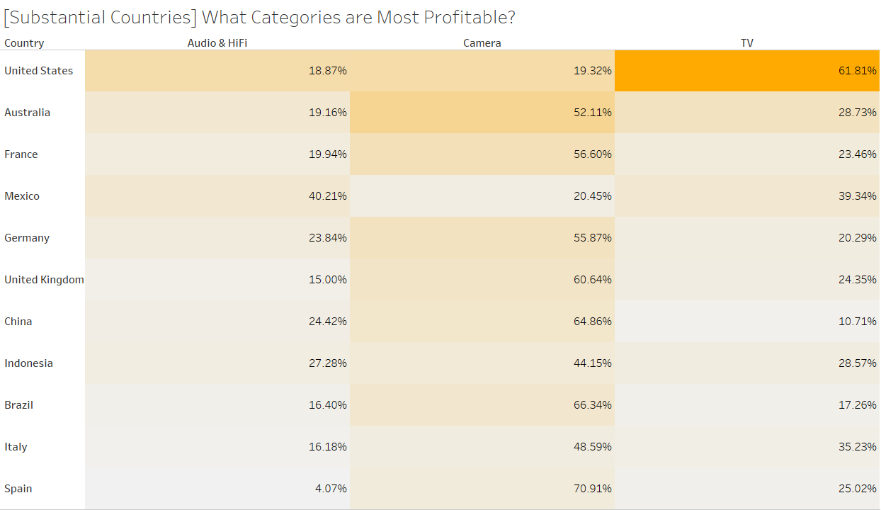
Figure 3-5. Profits of Categories Ordered by Country

Another highlight table was made to try to provide some insights to a follow on question from the previous highlight table: Does more quantity shipped out equate to more profits gained? Interestingly, the results were varied. A majority of the countries such as Australia, France, and Germany, conformed to this assumption as we can see that the Camera category brings in the most profit. However, countries such as the United States and Mexico bucked this trend as we see TV and Audio & HiFi being the more profitable Categories for these two countries respectively. This helped to dispel the preconception which would help in analyses for the other key factors to be explored.

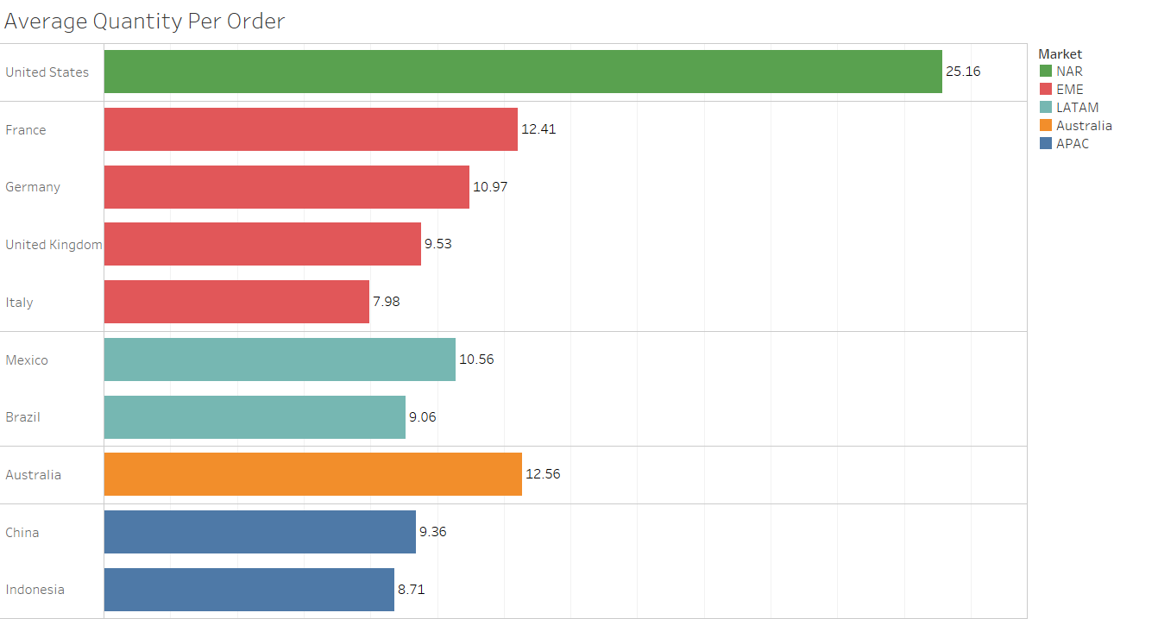
Figure 3-6. Average Quantity per Order

With the bar chart, we are able to compare the average quantity per order for each country. The countries are further separated by colour, into their markets. It is interesting to note no country within the Africa market features in this list.

Majority of Customer Base

Conclusions from this factor’s analysis will enable the business to be more efficient and effective in the directing of their energies.

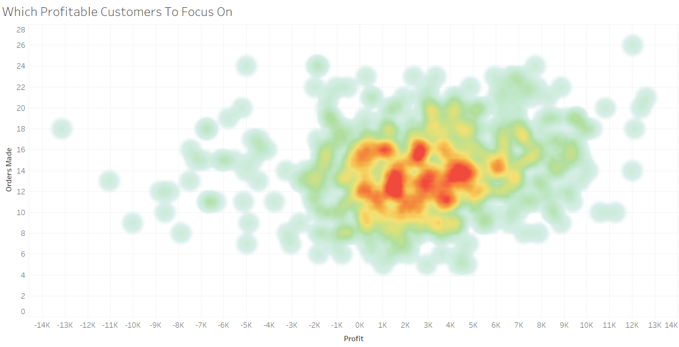
Figure 3-7. Density Map of Customers based on Orders Made

Using Count Distinct (not using Count because of the multiple Order Dates discrepancy that was found when cleaning the data) to find out how many distinctive times did a customer order from us, we can map out where the majority of our profitable customers lie; found on the positive side of the Profit axis, and where it is most dense. We can infer that the majority of customers have made between 8 to 18 orders with the company over the 2019 and 2020. This visualisation helps us to round up this majority customer set to help us in the subsequent analysis.

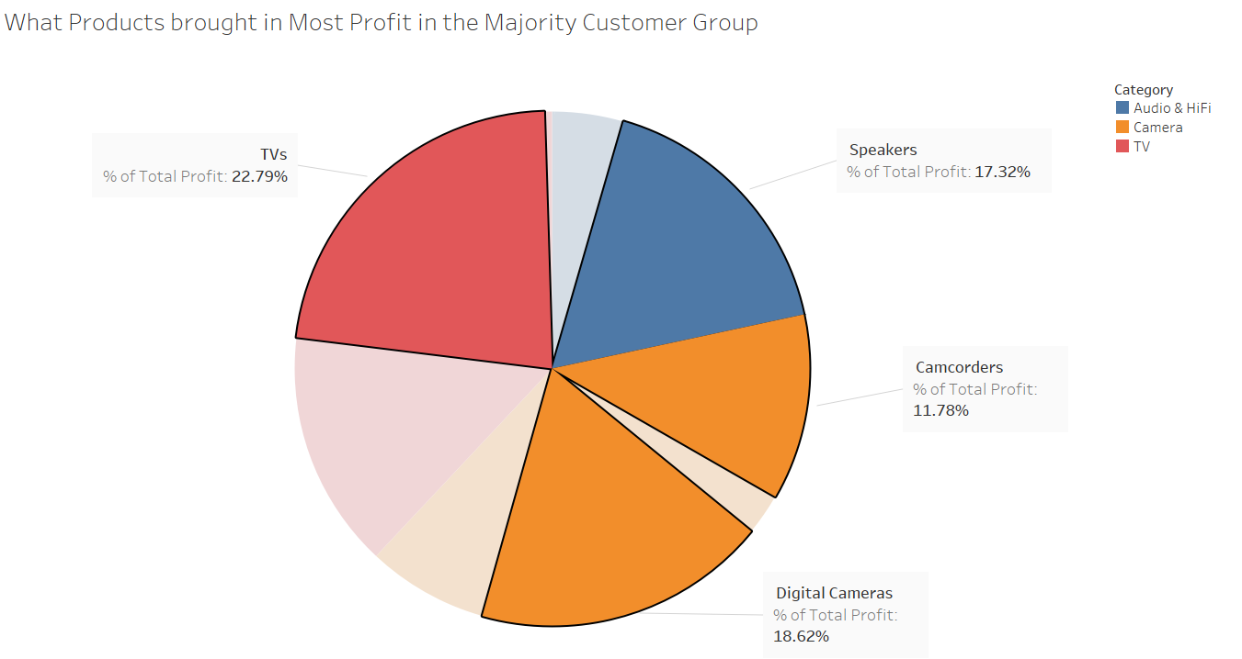
Figure 3-8. Pie Chart showing Majority Customer's Most Profitable Products

The pie chart has been filtered to only show the profits of the sub-categories of the majority customer set. Colour is used to differentiate the main categories, and the most profitable sub-categories have been highlighted. This visualisation can help the company to know which products to focus efforts such as marketing, promoting, and improve on to drive sales up for this majority customer set.

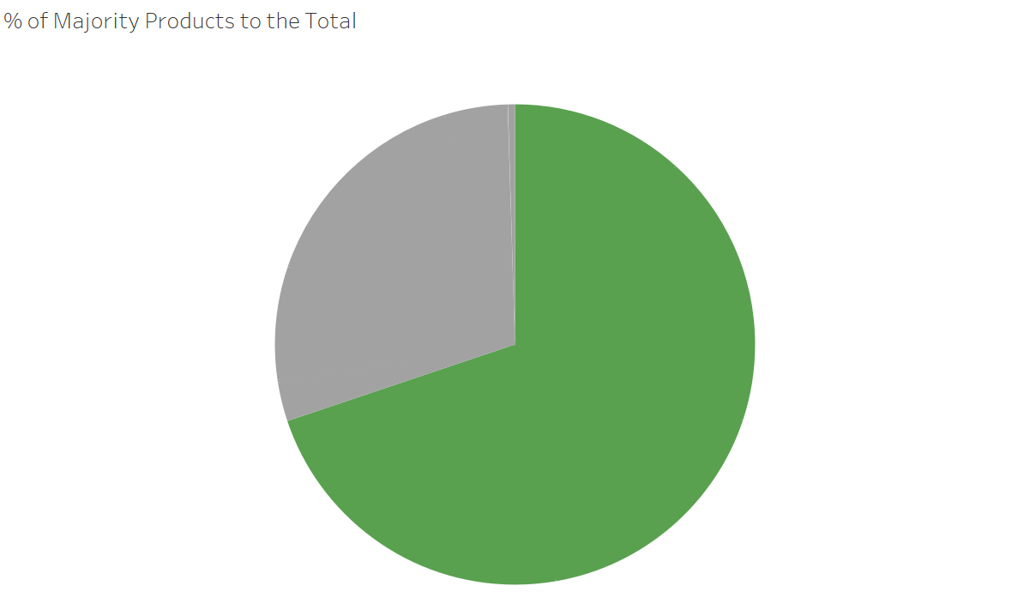
Figure 3-9. Amalgamated Pie Chart of Majority Customer's Profitable Products

This visualisation aims to provide the management with the oversight on the slice that the more profitable products (represented in green) contribute to the total profits for the majority customer sets. It is clear that the green slice is roughly 70% of the total profits.

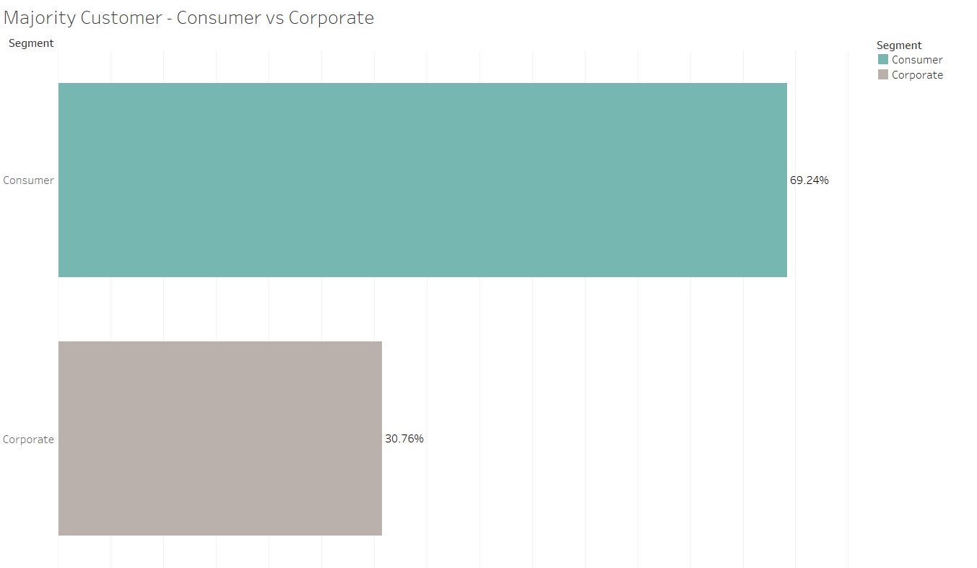
Figure 3-10. Majority Customer - Consumer vs Corporate

This bar graph helps to show the ratio of Consumer customers vs Corporate customers for the majority set. This can help to answer operational questions such as which segment should the marketing team focus on in future.

Trends to Note

This factor will present the business with profitable trends that they may look to jump on, affirm/deny on the profitability of certain products, and provide the business with data to highlight possible reviews in processes.
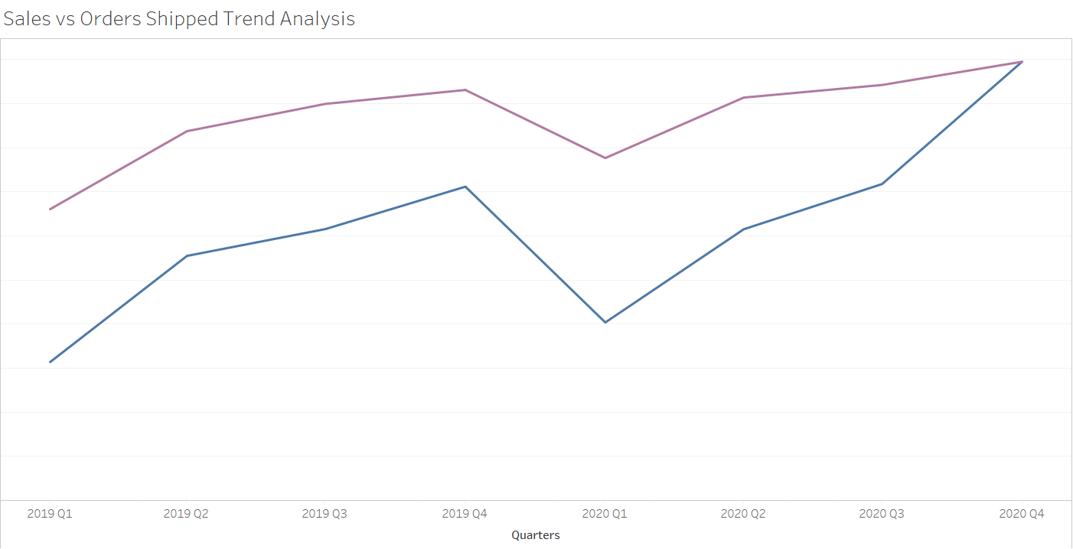
Figure 3-11. Sales Trend Analysis

In this chart, we can see that the orders shipped (purple) and the sales (blue) have an almost common trend in which both peak and trough in unison. There is just a mention of a slight dip in the sales vs orders shipped in Q2 to Q4 of 2019.

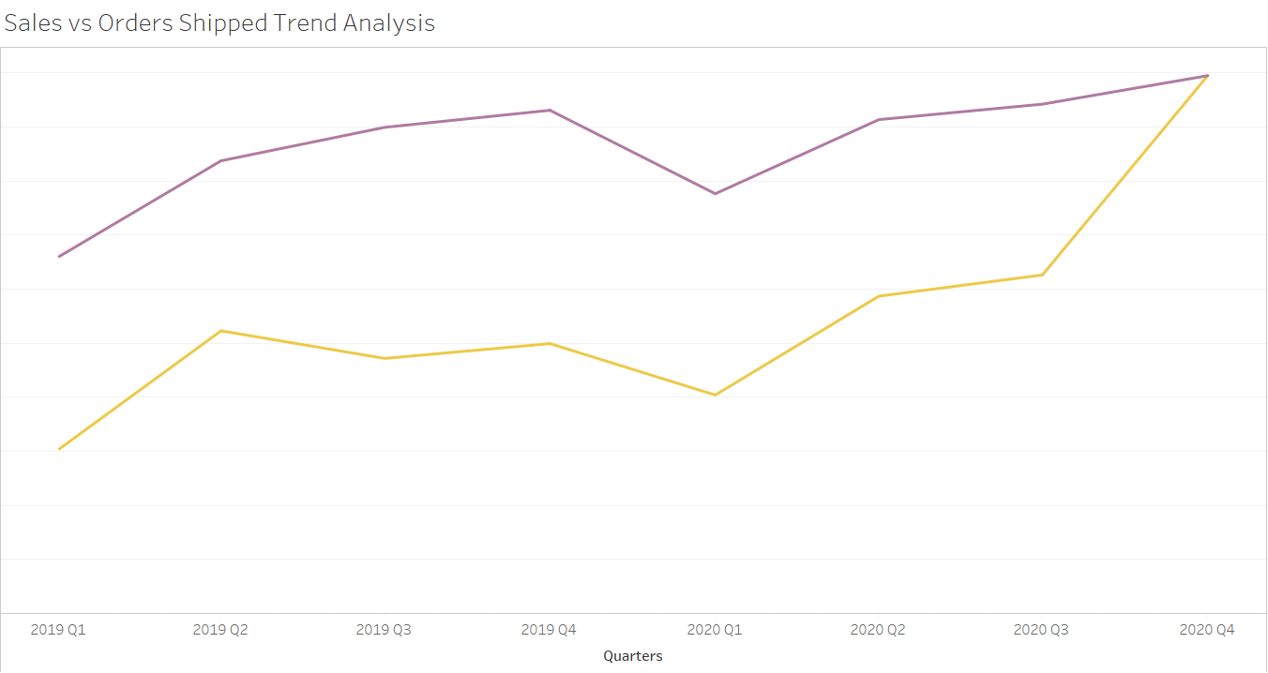
Figure 3-12. Profit Trend Analysis
When we take a look at the chart above comparing the profit vs the orders shipped, it is clearer that from Q2 to Q4 of 2019, the profit dips more obviously compared to the orders shipped. In contrast to this is the Q2 to Q4 profit line of 2020 which, much like the sales line in the previous chart, is moving in unison with the orders shipped. This helps us to open up queries to compare the sales trend of 2019 with 2020.

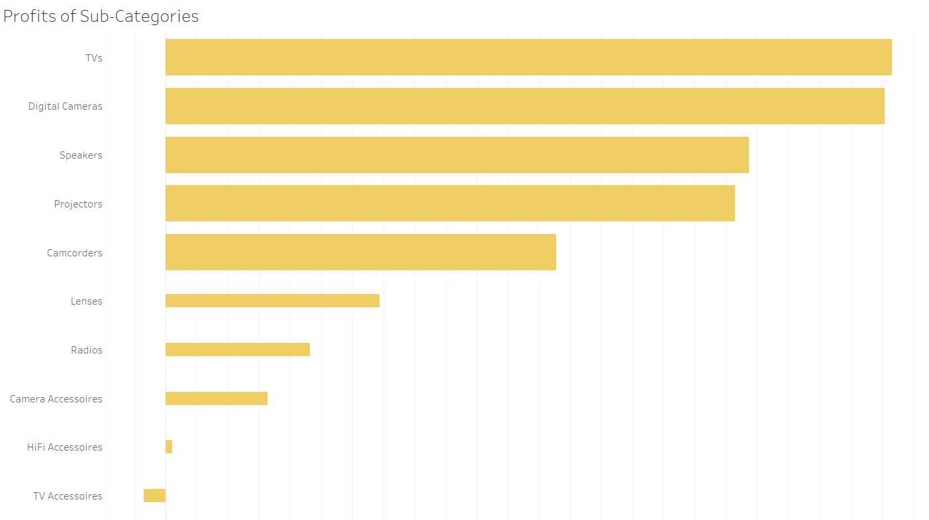
Figure 3-13. Profits of Sub-Categories

The chart above shows the profits of the sub-categories – sorted from most profitable to least. The sizes have also been adjusted to help differentiate between the top 5 most profitable sub-categories. It is interesting to note that TV accessories have been causing a loss to the company.

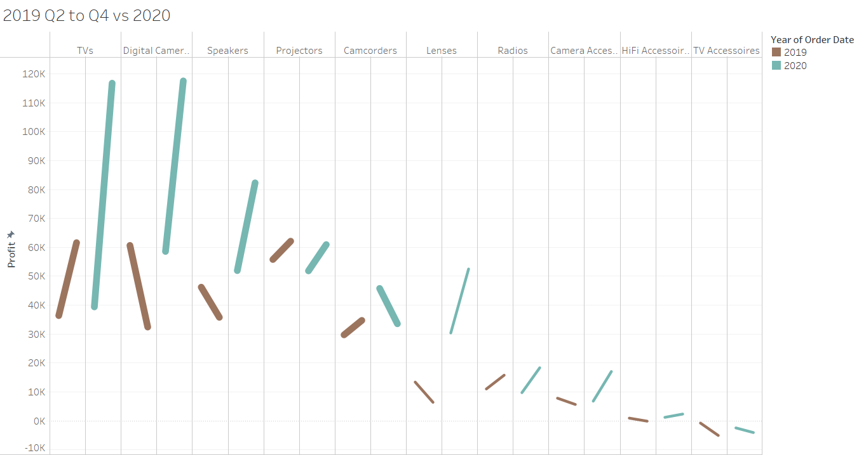
Figure 3-14. 2019 Q2 to Q4 vs 2020

The chart helps to visualise the trend in the profits for the sub-categories when comparing Q2 and Q4 of 2019 (brown) to 2020 (green). Some interesting insights present themselves: In 2019, sub-categories that hold significant weight in the company’s profitability such as Digital Cameras and Speakers actually dipped. In 2020, Camcorders dipped while Lenses, which were not in the top 5 most profitable sub-categories, significantly rose in profit compared to what happened to it in 2019.

DASHBOARDS

Optimise Shipping Dashboard

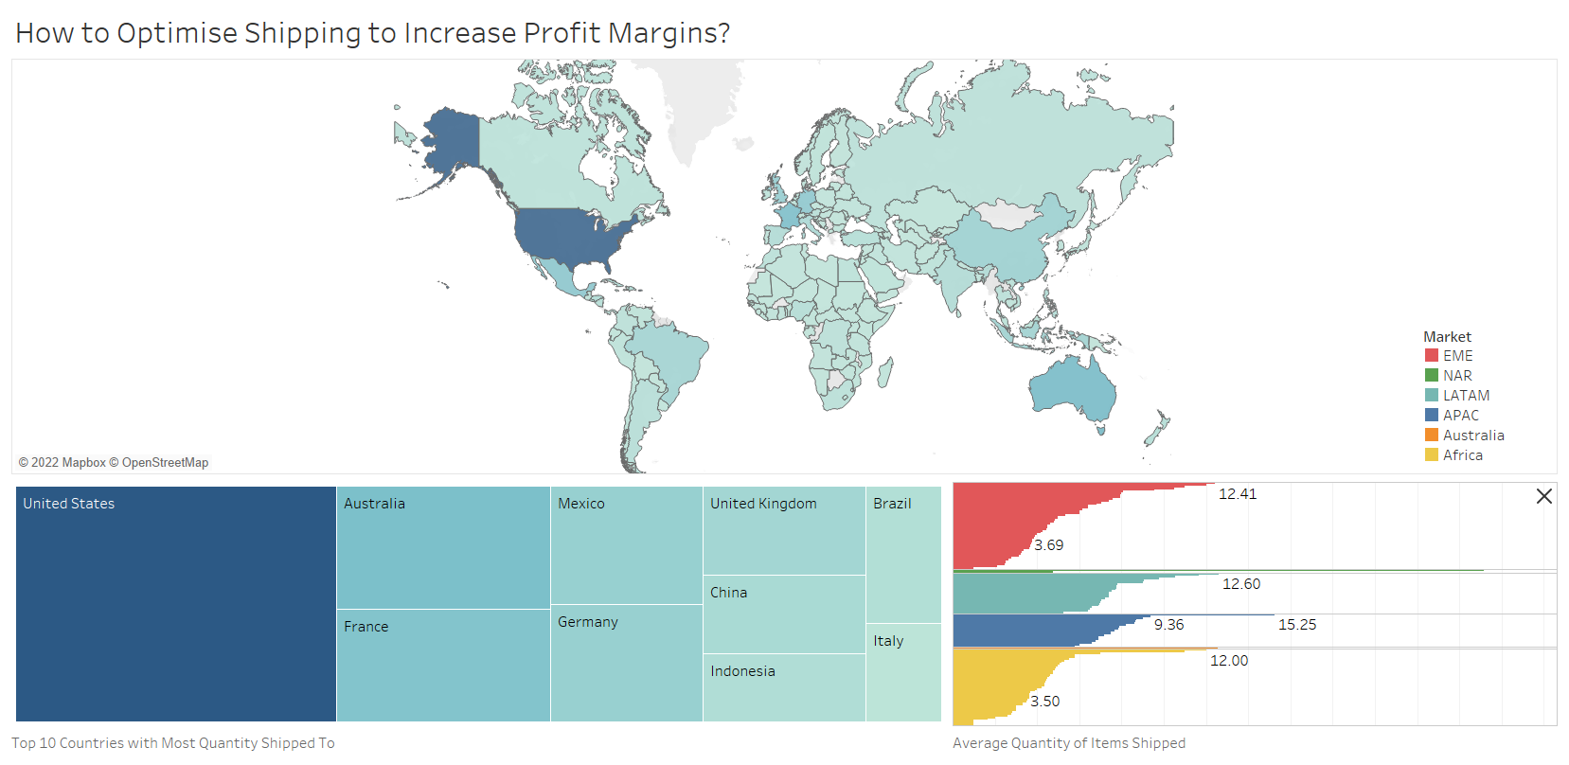
Figure 4-1. Optimise Shipping Dashboard

This dashboard helps provide the management with an overview of the quantities shipped to each country. This dashboard aims to provide the supporting data to recommend the following:
- Incorporate shipping perks such as shipping discounts or free shipping if ordering from the top few countries in order to increase the AOV.
- Graduated discounts leading up to free shipping upon hitting the country’s average quantity to reduce management’s shipping costs and increase AOV.

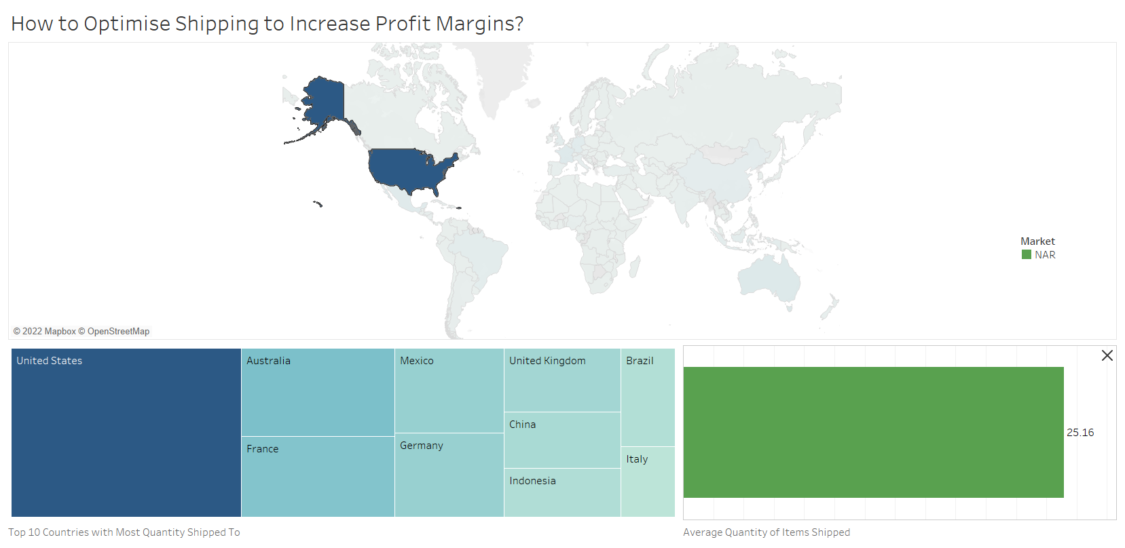
Figure 4-2. Action to Display Average Quantity Ordered for a Country

Certain actions have also been added to provide a level of interaction for the management’s perusal. For a start, a highlight action when selecting a country in the map shows the average quantity order in the bottom right view.

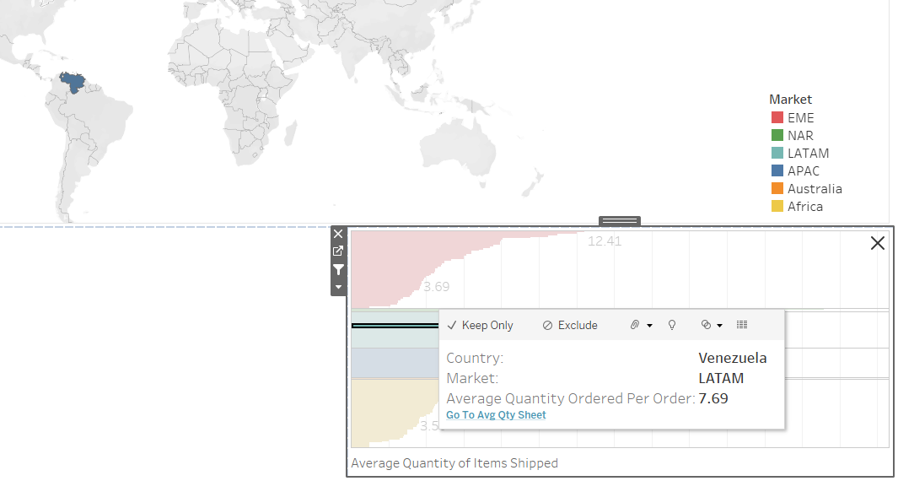
Figure 4-3. Go to Average Quantity Sheet

There is also an action created to allow the user to go to the average quantity sheet where he/she can filter the countries to view the average quantity as required (shown below).

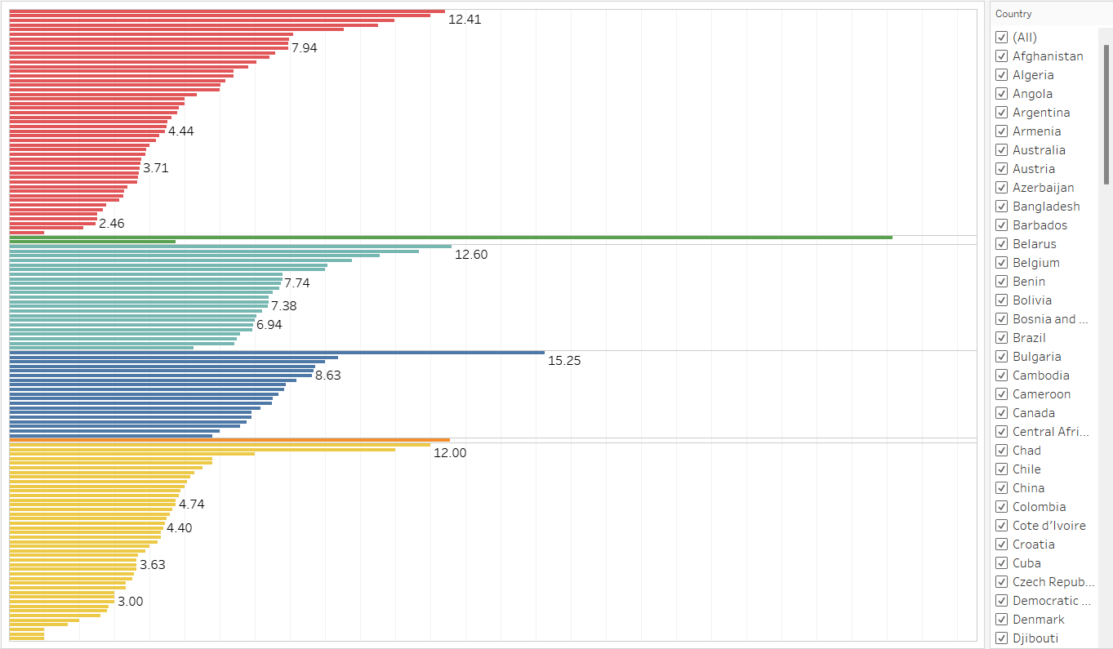
Figure 4-4. Filter Countries

Profit Trend Analysis Dashboard

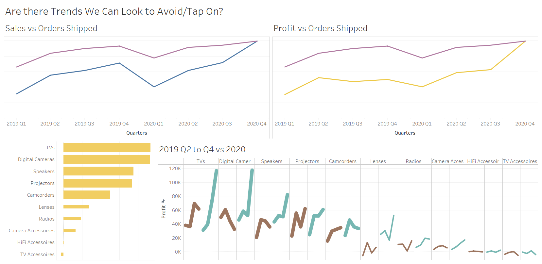
Figure 4-5. Profit Trend Analysis Dashboard

This dashboard aims to provide the management with a Trend Analysis to identify trends to avoid and follow to increase profit margins. From top right chart, we observe that the 2019 Q2 to Q4 profit dropped when the orders shipped increased compared to the 2020 Q2 to Q4 data. This observation is evidenced by the bottom right sheet which shows the top 5 profitable sub-categories experiencing a slow growth or a dip in profit in 2019 – compared to the 2020 data showing a high growth. It is also worth noting that profit of Camcorders in 2020 have dipped compared to Lenses. The recommendations are as follows:
- Aim to further promote the increasingly profitable items in the coming business year.
- Utilise strategies like “Complete your order” to advertise items that go together e.g. TVs and Speakers.
- Look to push sales of Lenses to ride on the growth while at the same time, conduct investigation to check on Camcorder dip.
- Investigate what were possible reasons for 2019 Q2 to Q4 dip vs 2020 Q2 to Q4. One reason could be COVID-19 causing people to buy less in 2019 vs buying more home/leisure electronics (TVs and Digital Cameras) in 2020 as more people work-from-home. However, the management should not take this as gospel truth till further data is collected and analysed.
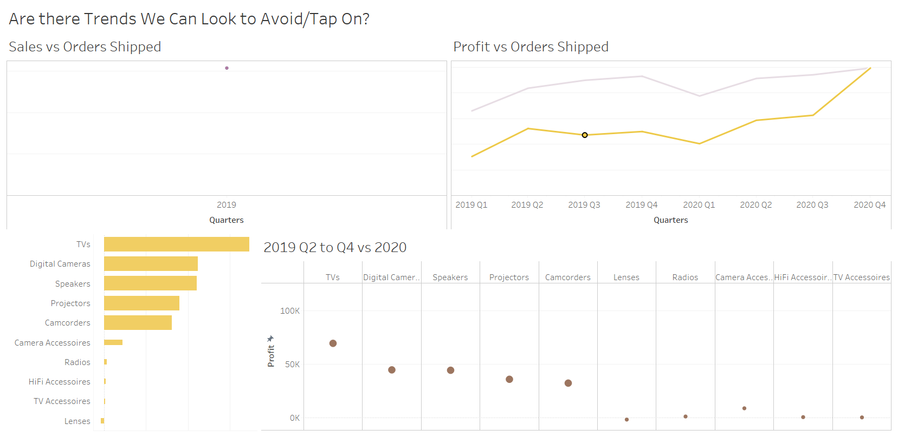
Figure 4-6. Filtering Profits when Selecting Quarter

Highlight actions have been created to allow the user to select the Quarter and display the profits for each sub-category in both charts at the bottom of the dashboard.

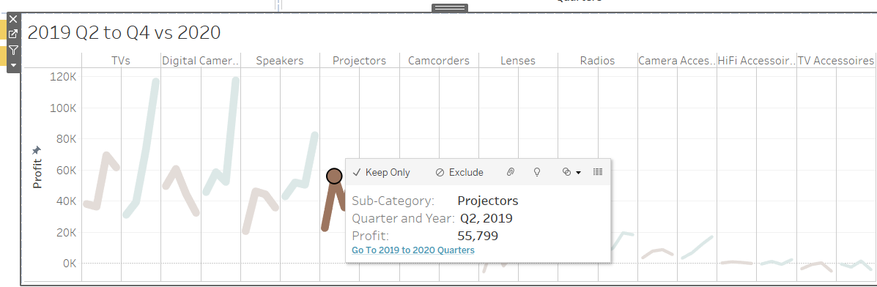
Figure 4-7. Go to 2019 to 2020 Quarters Sheet Action

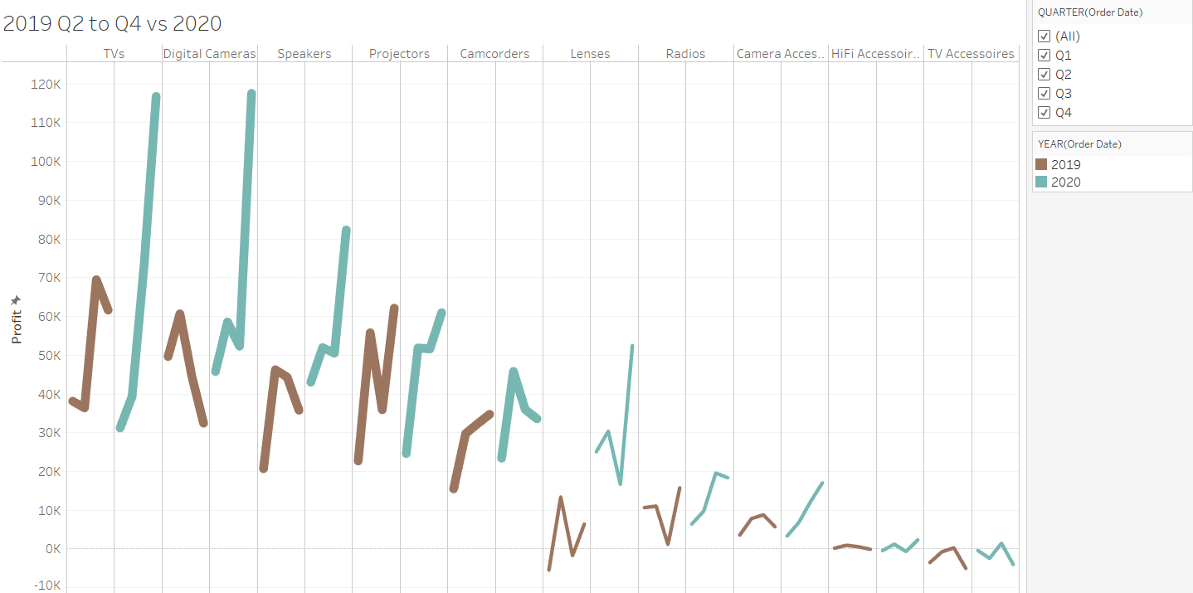
Figure 4-8. Filtering Quarters on Sheet

An action that allows the user to go to the 2019 to 2020 line chart has also been added to allow the user to filter the quarters (on the right of the chart) and view the trend as they like.

Customers to Focus On Dashboard

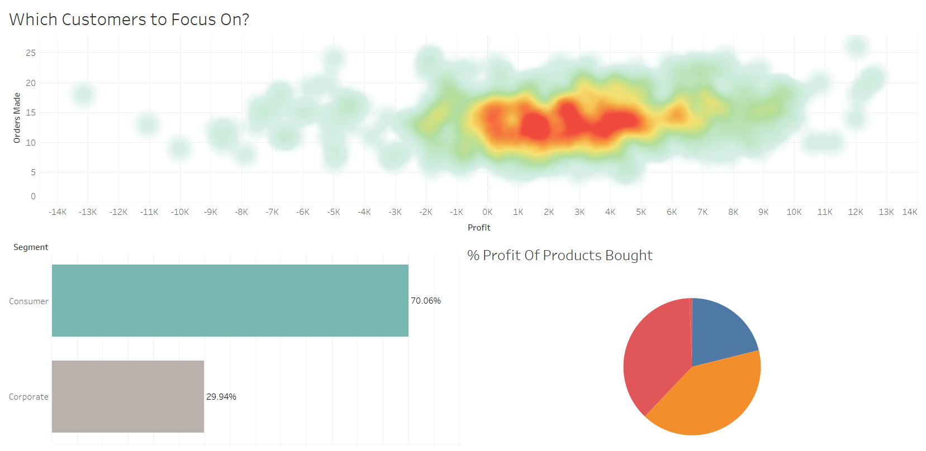
Figure 4-9. Customers to Focus on Dashboard

This dashboard aims to recommend to the management the following:
- Based on the density map, we can locate where the bulk of the profitable customers are. We can then inform the marketing team to target these individuals with promotions and discounts. This is to maximise efficiency in targeting a select group instead of every customer.
- By selecting all of the profitable customers, we can then observe what are the most profitable products, and push marketing of these items to this group to increase profit margins.

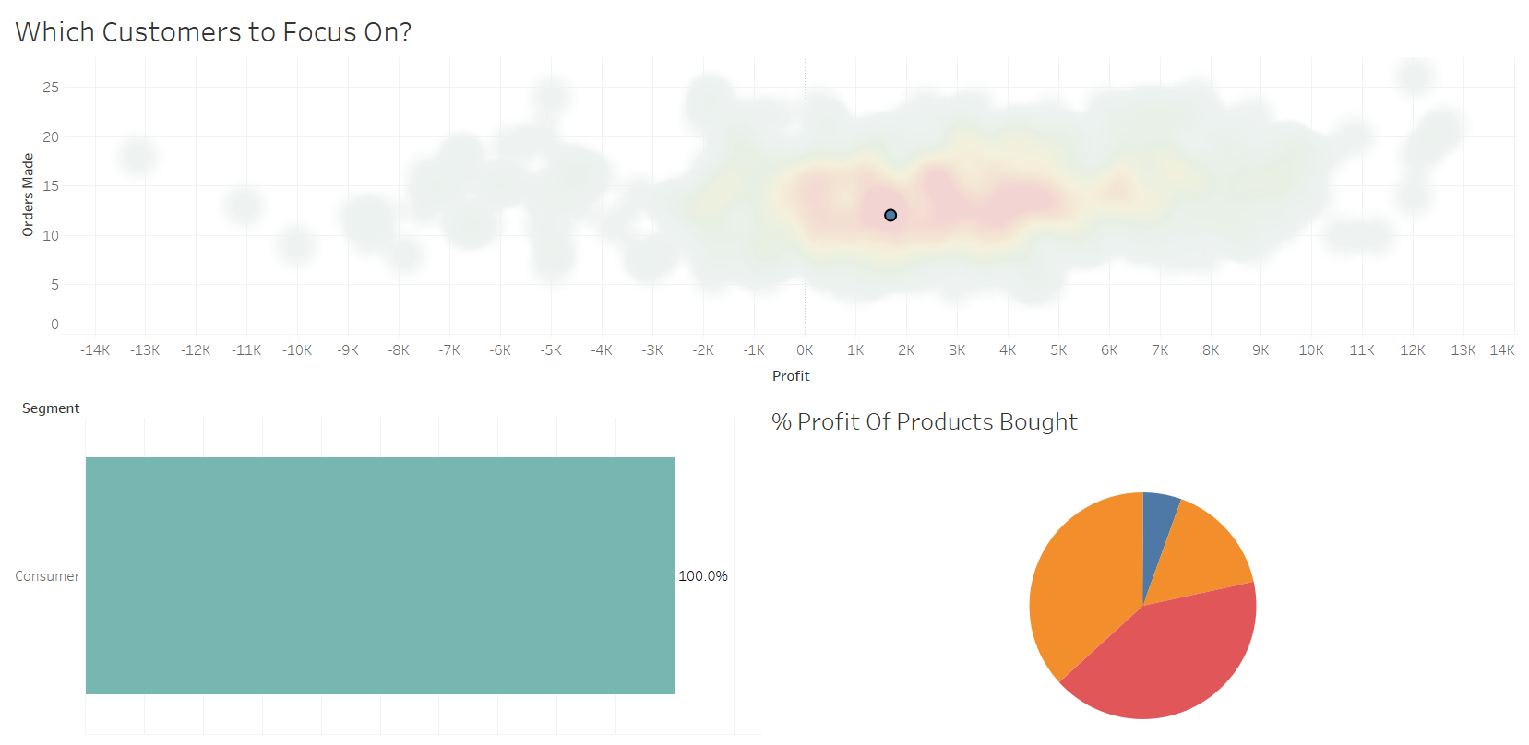
Figure 4-10. Filtering % of Profit of Sub-Categories for a Customer

The user can interact with this dashboard to highlight what sub-categories a customer bought contributed to the profit received from said customer. This action will also display whether the customer is a consumer or from corporate.

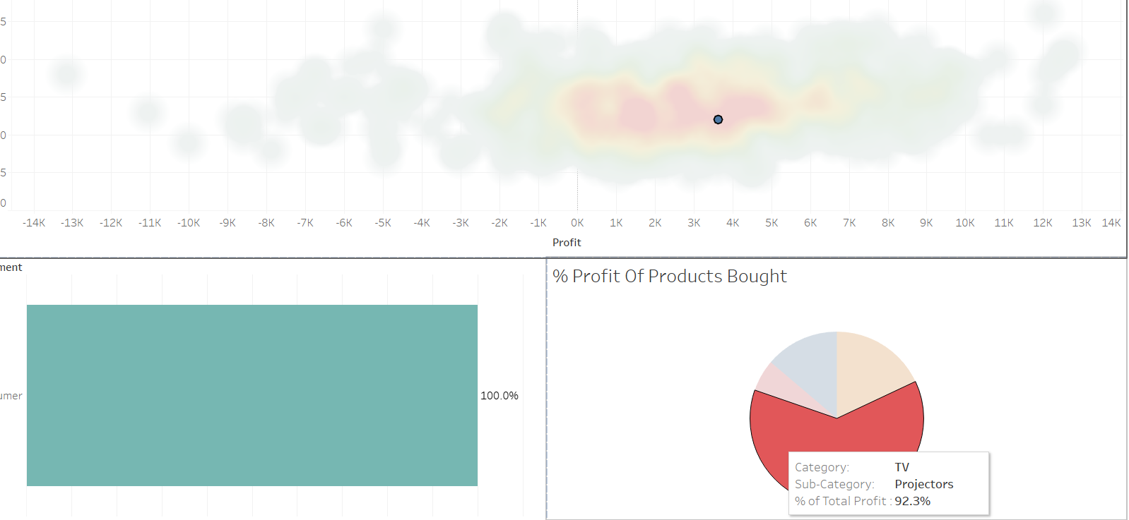
Figure 4-11. Hover Highlight Action

A hover highlight action for the bottom right chart has also been created to better distinguish and show details of a particular sub-category of a customer.

REFERENCES
Business, N. Y. (2022, January). Margins by Sector (US). Retrieved from https://pages.stern.nyu.edu/~adamodar/New_Home_Page/datafile/margin.html
Dykes, B. (2020, August 11). Forbes. Retrieved from forbes.com: https://www.forbes.com/sites/brentdykes/2020/08/11/a-simple-strategy-for-asking-your-data-the-right-questions/?sh=3f7d9cbab9a7

